Lesson 12: What materials best reduce the peak forces in a collision?

Previous Lesson | We revisited our anchor and discovered that some phones were in cases when they were damaged. We developed new phone case criteria and constraints and designed a protection device for something new. We received design feedback and developed an encompassing set of criteria and constraints.
This Lesson  Investigation  2 days   | 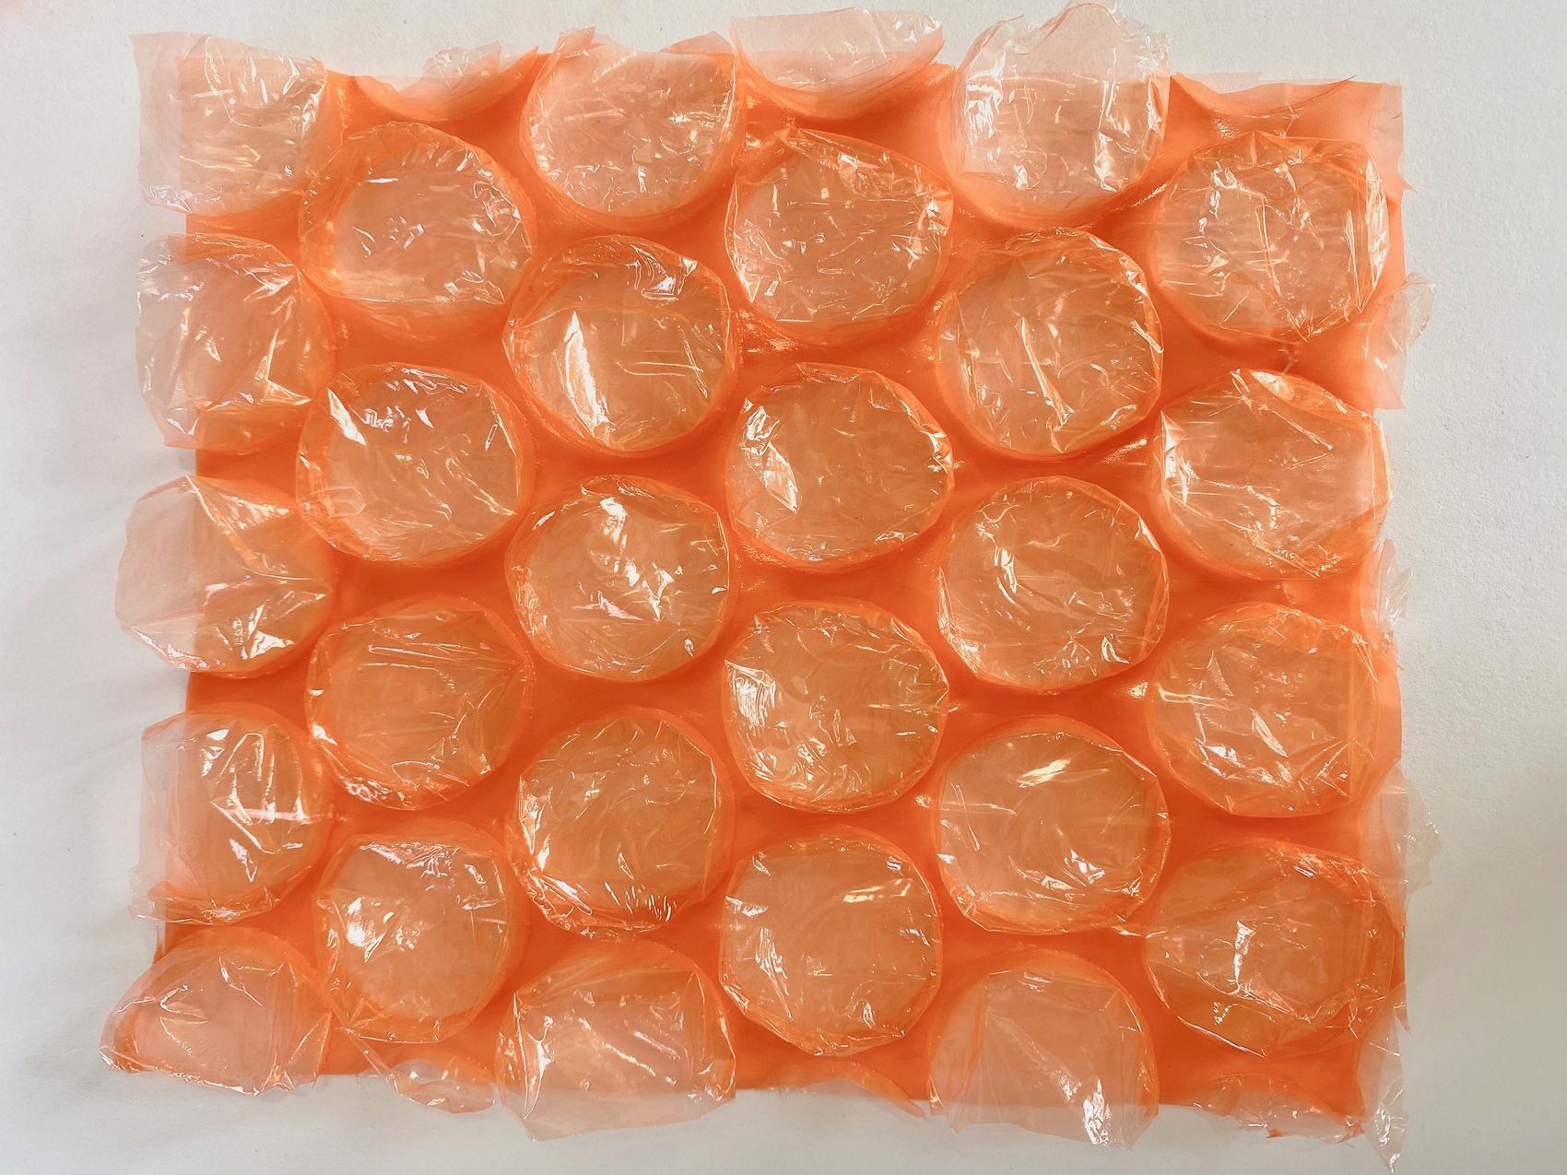 | We conduct an investigation to determine what easily accessible materials reduce peak force in a collision. We compare the structure of the materials and find similarities in their compositions that might affect their function. We also determine that the peak force is reduced equally on both objects, regardless of size. We try to develop a model to explain how the structures of the materials function in a collision that helps to reduce peak forces on the objects we want to protect.
Next Lesson | We will develop a model to represent how the structures of materials compare in the top four performers for peak force reduction. We will use scaled-up versions of these structures to generate data using slow-motion video about the unobservable mechanisms at work in the system. We will carry out an investigation to determine how the amount of force applied to different points of a cushioning structure is affected by the shape of that structure.

BUILDING TOWARD NGSS  MS-PS2-1, MS-PS2-2, MS-PS3-1, MS-ETS1-2, MS-ETS1-3, MS-LS1-8   | What students will do  12.A Analyze data to determine which materials reduce peak force in a collision and analyze the similarities (visual patterns across materials) in the properties of those materials (macroscopic deformability).  12.B Develop a model to explain how the changes in the structures of cushioning materials contribute to their function (a reduction in peak forces) at a microscopic level during a collision.  What students will figure out  - Materials that reduce peak force have similar structures, such as air pockets or space for air, and the ability to deform when a contact force is applied; these materials reduce the peak force equally on both objects involved in the collision.

Lesson 12 • Learning Plan Snapshot
Part | Duration |  | Summary | Slide | Materials
1 | 4 min |  | NAVIGATION  Review the previous lesson and determine the basic materials testing setup. | A-B
2 | 10 min |  | INTRODUCE MATERIALS AND MAKE PREDICTIONS  Create a chart of potential protective materials in science notebooks and predict the effect of different materials on peak forces. Share ideas by taking a class poll. | C-E | Material Charts (optional), 1 set of each of the prepared test materials, cotton balls, balsa wood, foam earplugs, styrofoam, cardboard, metal, CD case, large bubble wrap, small bubble wrap, fabric
3 | 12 min |  | DETERMINE BASELINE PEAK FORCE AND DELEGATE TESTING OF MATERIALS  Demonstrate the setup for measuring peak force reduction and take a baseline without any potential reduction materials in the system. | F | Materials Testing Lab
4 | 18 min |  | CONDUCT MATERIALS TESTING | G-I | Materials Testing Lab

End of day 1
5 | 6 min |  | COMPARE CLASS DATA  Compare class data for various materials and make initial claims about materials. | J
6 | 4 min |  | REVIEW DATA AS A CLASS  Look at materials data as a class and determine which materials reduced peak forces best. | K | Up Close Images, Force Reduction Chart
7 | 8 min |  | COMPARE FORCES ON BOTH OBJECTS WITH PROTECTIVE MATERIALS  Use different spring scales with and without force-reducing materials to determine that the peak forces on each object are equal with and without protective material. | L-M | 1 5-N spring scale, 1 10-N spring scale, 1 force-reducing material from Materials Testing Lab
8 | 8 min |  | COMPARE MATERIALS AND EXPLAIN MATERIAL STRUCTURE  Look at different peak-force-reducing materials and compare their structures. Develop an initial explanation of how the materials help to reduce peak force when a contact force is applied. | N-O | How do we sense different textures? (optional), Up Close Images
9 | 14 min |  | CONSTRUCT INDIVIDUAL MATERIAL EXPLANATIONS  Use bubble wrap and cotton balls to develop an explanation of how the properties of the protective materials behave to reduce the amount of peak force when a contact force is applied. | P | 1 1”-square piece of small bubble wrap, 1 cotton ball, How can materials reduce peak force on the objects they protect?

End of day 2

Lesson 12 • Materials List
 | per student | per group | per class
Materials Testing Lab materials | - safety goggles | - 2 5-N spring scales attached to 2 carts with hook and loop fasteners with a twist tie force collar on one spring scale plunger  - 2 electrical plates  - 1 vinyl flooring strip  - textbooks or binders to lift track 8”-12”  - 2 of the same test material (type of material will vary per group)  - 1 aluminum track  - 1 brick  - 2 pieces of sticky tack  - 1 container of clay  - 1 ruler or measuring tape  - transparent tape  - 1 strip of duct tape  - Cushioning Materials Testing Procedures | - Force Reduction Chart  - digital scale  - 2 5-N spring scales attached to 2 carts with hook and loop fasteners with a twist tie force collar on one spring scale plunger  - 2 electrical plates  - 1 vinyl flooring strip  - textbooks or binders to lift track 8”-12”  - 2 of the same test material  - 1 aluminum track  - 1 brick  - 2 pieces of sticky tack  - 1 container of clay  - 1 ruler or measuring tape  - transparent tape  - markers
Lesson materials | - science notebook  - Material Charts (optional)  - Up Close Images  - How do we sense different textures? (optional)  - 1 1”-square piece of small bubble wrap  - 1 cotton ball  - How can materials reduce peak force on the objects they protect? | - 1 5-N spring scale  - 1 10-N spring scale  - 1 force-reducing material from Materials Testing Lab  - Up Close Images | - 1 set of each of the prepared test materials  - cotton balls  - balsa wood  - foam earplugs  - styrofoam  - cardboard  - metal  - CD case  - large bubble wrap  - small bubble wrap  - fabric  - Force Reduction Chart

Materials preparation (25 minutes)

Review teacher guide, slides, and teacher references or keys (if applicable).

Make copies of handouts and ensure sufficient copies of student references, readings, and procedures are available.

Day 1
- Consider printing a chart for each student from Material Charts. Cut into individual charts for student use. Students can also draw this chart in their notebooks. Students with writing difficulties or accommodations could benefit from a copy, which would reduce the amount of writing.
- At the end of the day, collect and reserve the test materials to have on hand for day 2.
Day 2
- Cut a small piece of small bubble wrap (roughly 1” x 1”) for every student.
- Decide if students will be allowed to pop the piece of bubble wrap after completion of their model.
- If students are allowed to pop the bubble wrap, cut enough wrap for every student in every class.
- Make a plan for collecting bubble wrap (used or unused) after the activity. Depending on the material, some types of bubble wrap can be recycled. Check for the recycling symbol on the bubble wrap packaging.
- Have large cotton balls available for all students (one per student).
- Make a plan for collecting cotton balls after the activity.
- Have all spring scales available for partner pair use.
- Have available the reserved testing materials (1 material per partner pair).
- Make enough copies of How can materials reduce peak force on the objects they protect? for all students.

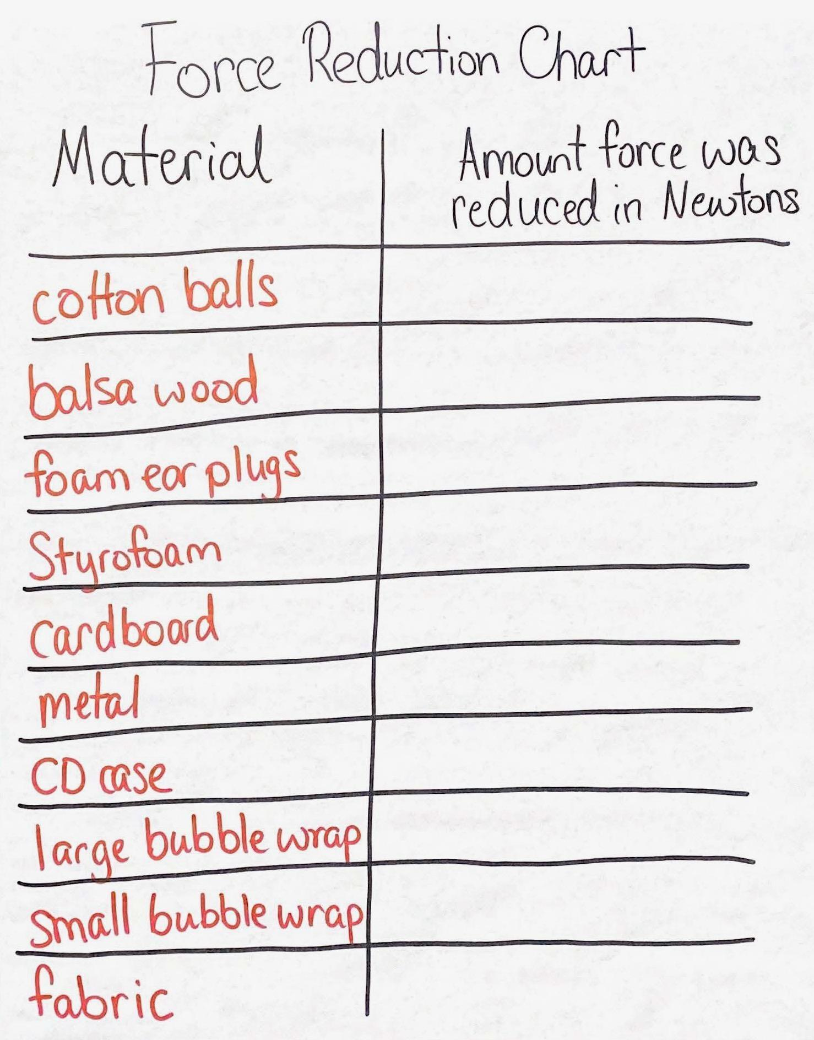
Day 1: Materials Testing Lab
- Group size: 3-4 students
- Setup
- Determine a way to allocate different testing materials to student groups. Some ways include pulling sticks, counting off 1 through 10, and drawing a number out of a bucket.
- Create the Force Reduction Chart.
- Watch video https://youtu.be/3HZgumZXbK0 to set up a teacher demonstration station.
- Set up collision carts demonstration (see Setup for Collision Carts Demonstration for images of these steps):
- Add textbooks or binders to elevate one end of the flooring strip 8”-12” to create a ramp.
- Angle the lower end of the vinyl flooring strip into the brick.
- Place the metal track on the vinyl flooring strip and with its lower end against the brick.
- Place the push-pull spring scales on the carts using the hook and loop fasteners.
- Mount a plastic, blank electrical plate on the end of the rod on each of the 2 push-pull spring scales using sticky tack.
- Make sure that the two electrical plates touch flush when the carts are pushed together.
- Using duct tape, tape down one cart at the bottom of the ramp about 4 inches away from the brick with its plate facing up the ramp.

- Prepare materials for student use.
- Gather testing materials for each class:
- 8 large cotton balls
- 2 balsa wood slices
- 8 foam earplugs
- 2 4” x 2.5” pieces of Styrofoam
- 2 4” x 2.5” pieces of cardboard
- 2 quarters or other flat pieces of metal objects such as washers
- A single piece of the flat plastic from a CD case (cover preferably)
- 2 4” x 2.5” pieces of large bubble wrap
- 2 4” x 2.5” pieces of small bubble wrap
- 2 4” x 2.5” pieces of terry cloth fabric
- Larger testing materials listed above (bubble wrap, balsa wood, cardboard, CD case pieces, fabric, Styrofoam) should be cut to a size that allows for the materials to easily fit onto the front of the electrical plates (roughly 4” x 2.5”). If the balsa wood comes in a smaller size, it will still function correctly as long as the wood is lined up well with the opposite piece of balsa wood on the opposing electrical plate.
- The CD case will need to be taken apart. It may be easier for students to use the CD case front on one electrical plate and the CD case back on the opposing electrical plate. This is fine as long as the plate does not drag on the aluminum track.
- Prepare student lab stations per group:
- Print 1 copy of Cushioning Materials Testing Procedures per group. A color copy can also be found in the Student Procedures.
- Provide the following materials for every student station.
- 8” of transparent tape
- 1 12” strip of duct tape
- 2 blank electrical plates
- 2 pieces of sticky tack (can already be attached to plungers)
- 1 piece of vinyl flooring
- textbooks or binders to elevate ramp (Keep the height consistent across groups to help account for drop angle.)
- 1 piece of aluminum track
- 2 5-N spring scales attached to 2 carts with hook and loop fasteners with a twist tie force collar on one spring scale’s plunger
- 1 container of clay
- test materials
- Notes for during the lab
- While students are engaging in the lab, circulate to make sure the twist tie force collar is getting reset in between each trial.
- Check that students are consistently measuring the force from the same side of the twist tie force collar (front or back).
- Make sure that students are pulling back the moving cart to the same spot consistently each trial.
- Safety
- Wear safety goggles or glasses during the setup, hands-on, and take-down segments of the activity.
- Carts can fall off the tables if a brick is not placed at the end of the track. Make sure each station has a brick at the end of the track.
- Bricks are heavy and can cause injury when dropped on body parts. Make sure all bricks are away from edges of tables or areas where there is a drop risk.
- Make sure all fragile items are removed from the test area.
- Secure loose clothing, remove loose jewelry, wear closed-toe shoes, and tie back long hair.
- Immediately pick up any items dropped on the floor so they do not become a slip or fall hazard.
- Storage
- All materials from this lab can be stored and reused indefinitely.

Lesson 12 • Where We Are Going and NOT Going

Where We Are Going

Students will compare the data gathered from the testing of multiple materials to analyze similarities and differences in the peak force reduction of different materials. Students will compare the microscopic structures of those materials to determine what properties of the materials might contribute to peak force reduction when a contact force is applied.

Where We Are NOT Going

While students may be identifying or be assessed on similar properties of force-reducing materials, students will not be altering their designs with new findings until a later lesson. Students will also not be making a conclusion that one protective material is definitively better than another. In the next lesson students will be weighing other criteria and constraints against the materials to learn that each material has a trade-off. Students will not be coming to consensus about the molecular-level interactions that lead to a greater force reduction in this lesson. The data collection will be limited to forces parallel to the surface of the track. This is treated as a set of horizontal interactions between the push-pull spring scales and cushioning material, even though the track is slightly tilted. The vertical forces in the system (e.g., gravity) and forces perpendicular to the track surface (e.g., normal forces) will not be discussed.

LEARNING PLAN for LESSON 12
1 · NAVIGATION | 4 min
MATERIALS: None
Recall criteria for our protective device from the previous lesson. Project slide A. Say, Let’s look back at our criteria list from last time. We know that in order to have an effective protection device design we need to meet our criteria. One criterion we identified was using materials that will protect our object. What does that mean?

Suggested prompt | Sample student response
What does it mean to use good materials that are protective? What would those materials do? | It means the materials reduce peak force on the object in the design.  The materials are designed to protect objects.
How do you think those materials function? | Maybe the materials move more before they reach their elastic limit.  The materials might squish.
How do we think those materials help reduce peak force in a collision? | The materials might absorb some of the energy being transferred to or through it.  Maybe they give or deform more easily.

Say, It sounds like we have some varied ideas on what exactly it means to have a protective material and what that material does to help reduce the peak forces in a collision. We need to figure out which materials would best fit the goal of protection for our objects. Turn and talk with a partner about other things we have done to measure peak force that we might be able to reuse today.

Share protective material ideas. Project slide B. Give students a moment to turn and talk. Once students have had a chance to talk with a partner, bring the class together and have students share their ideas. Example prompts and responses are below.

Suggested prompt | Sample student response
How have we measured peak force in the past that we could reuse or repurpose for our investigation today? | We had a lesson where we used peak force collars on spring scales to see the amount of peak force in a collision.
How can we use that to test different materials’ peak force on objects in a collision? | We’d have to use the same setup and add the materials to it.
So if we add our protective materials in front of the object we are protecting and then collide a moving object into it, we could see if the peak forces were reduced?  Great! It sounds like we have a general plan to test our materials. | Yeah.

ADDITIONAL GUIDANCE | If students have trouble coming up with the idea of using the peak force collar on a spring scale, direct students to look back in their Progress Trackers for a time when we were learning about peak force. Ask them what investigation was done to learn about peak force and what materials were used. Guide students to the idea of using the same setup that was used in a previous test, but adding in the potential protective materials that we want to use in the collision-cart interaction.

2 · INTRODUCE MATERIALS AND MAKE PREDICTIONS | 10 min
MATERIALS: science notebook, Material Charts (optional), 1 set of each of the prepared test materials, cotton balls, balsa wood, foam earplugs, styrofoam, cardboard, metal, CD case, large bubble wrap, small bubble wrap, fabric
Tell students that after looking at their designs from the gallery walk in the last class and seeing the materials they used, you were able to find certain comparable materials around the classroom for them to test.  Make protective material predictions. Project slide C. Show students each material. Either pass out to each student a copy of the materials chart from Material Charts or have students create in their notebooks the chart from slide C.✱ Ask students to make predictions about which materials will better reduce peak forces in a collision. Students will add the following markings in the second column on their charts to indicate their predictions:  - + if the material will increase peak forces during a collision  - - if the material will reduce peak forces during a collision  - = if the peak forces will remain the same during a collision  Ask students to look at the materials for which they marked a minus. Have students circle a material with a minus that they think will do the best job of reducing peak forces in a collision.  Share ideas with a partner. Project slide D. Once students have had a chance to make predictions about materials, have them turn and talk with a partner about their predictions. Have students use the following questions to guide their partner discussion:  - What material do you think will reduce peak force the most? Why?  - What material(s) do you think will perform the worst? Why?  Take a class poll over materials ideas. Project slide E. Bring students together and have them share their ideas on the best and worst performers by taking a class poll for each. For the first poll, read out loud each material listed in the chart, pausing after every one. Have students raise their hand if they think the material will be the best performer. If any material has several hands raised, ask students why they think that the material would be the best at reducing peak forces. Continue the process of reading the materials, taking a poll, and asking students their reasoning until all materials have been read.  Take a second poll, Ask students which materials would do the worst at reducing peak forces. Explain to students that this could mean that they are reducing the forces very little or not at all or even increasing the forces. Read through the list of potential protective materials again, pausing after each one to take a poll, and, for materials that have several hands raised, asking students why they think that particular material would do the worst at reducing peak forces. Accept all answers. Keep going until all materials on the list are read.  Say, Interesting. It seems that we have different ideas on which materials would be best to use in our designs and even which materials we would want to avoid for protective purposes in our designs. We also have some ideas about why those materials might work or not work, but we aren’t sure. We’ll need to collect some data to see which of our predictions are supported and which are refuted by the evidence. | ✱ ATTENDING TO EQUITY  Universal Design for Learning: Material Charts is provided as a scaffold to save time from students having to copy the chart from the slide. In addition, it can be used as a support for students who struggle with copying from a slide into their notebook with enough room to record data to be able to engage with the activity.
  ADDITIONAL GUIDANCE | Universal Design for Learning: Taking a poll allows for students to engage in presenting their ideas in a low-risk manner. Students can share their ideas without being pressed to go public individually and/or to explain their predictions without specific evidence to cite. By asking the entire group about the identification of certain materials falling into the categories of being best or worst performers, not just the students who have their hand raised, students feel less pressured to make a prediction about a material as their classmates can chime in and give their perspective on the polling choice.

3 · DETERMINE BASELINE PEAK FORCE AND DELEGATE TESTING OF MATERIALS | 12 min
MATERIALS: Materials Testing Lab
Determine materials lab setup. Project slide F. Show students the basic setup at the demonstration table. Draw attention to the peak force collar that was used in Lesson 5. Ask students the following prompts:  - We want to see if our materials reduce the peak force in a collision.  - Where would we have to place the material so that we could see if it reduces the peak forces on our colliding objects?  - How can we secure the test materials in place when we are running our tests?  Discuss the two questions as a whole group. Students should determine that the potential protective material should be placed in the middle of the collision, in between the two objects that are colliding.  Explain material setup.  Review force collar use.  Create the need for multiple trials. Now that students have had a chance to view the setup, say, Let’s do this demonstration one more time to make sure we know how it works.  Intentionally lift the cart to a slightly different height on the track and release the cart. Have a student read where the force collar rests. Point out that it is at a slightly different spot.  Ask students:  - Will we always get the exact same results?  Students should respond that it depends on the trial and that small differences can occur. Ask students what we can do to account for these small differences. Elicit the idea that we can take an average of the data to account for small differences in how we release the cart and other variables that are hard to control.  Controlling for other factors. Explain that we will also have to keep track of the mass of our carts. As we figured out in Lesson 5, the mass affects the amount of kinetic energy an object has, which in turn affects the peak force. Because of this we will use a digital scale to make sure all carts weigh exactly 200 g. Show students how to add clay to the cart cavities on top to adjust the weight of the cart to 200 g.  Run the demonstration at least 2 more times to demonstrate to students how to check for semi-consistent results. Explain to students to look at their data once they are finished. If there is a larger variance than +/- 0.2 N from the mode of their measurement, check that the collar isn’t loose and rerun that trial.✱  Introduce Force Reduction Chart. Post the Force Reduction Chart in an easily accessible part of the room for students. Explain to students that they will be splitting up to test different materials listed on the chart. These materials are readily available, and while they may not reflect all materials they are wanting to use in their design, the materials we have to test have very similar features.  Assign groups and distribute test materials. Divide the class up into groups to test the materials. Label the materials 1-10. Randomly assign the materials to groups using the method determined in the Lab Preparation section of the Teacher Guide, such as choosing sticks, counting off by 10, and so forth. Have a student from each group collect the testing materials for their group. Explain that they will not be given extra materials, so they should use the materials carefully. Bubble wrap and other materials should not be popped or destroyed. | ✱ SUPPORTING STUDENTS IN ENGAGING IN PLANNING AND CARRYING OUT INVESTIGATIONS  In the next step, students will receive Cushioning Materials Testing Procedures. While students are checking their data for variances after their materials testing, they may find that there are variances larger than the allowable amount and that do not meet the goals of the investigation. From this point, students will have to assess what potential revisions were imparted on the experimental design for the variance in data and then revise their data collection method to better align with the class data collection protocol for this lab.  ✱ ATTENDING TO EQUITY  Universal Design for Learning: Some students may be able to physically manipulate materials better than others due to motor skill differences. When assigning materials, it may be helpful to keep in mind the effort it takes to attach the materials to the carts. It also might be helpful to have ready-made tape loops for students to use. If something other than transparent tape is used, make sure that it is very lightweight so that the mass is not affected from cart to cart.  Easy-to-attach items  - cotton cloth  - balsa wood  - cardboard  - small bubble wrap  Harder-to-attach items  - cotton balls  - earplugs  - metal  - Plastic piece from CD case  - Large bubble wrap
  Arrange students around the demonstration table. Explain to students that some materials will not fit onto the plungers, so we will be adding an electrical plate to the front of each cart using sticky tack. | 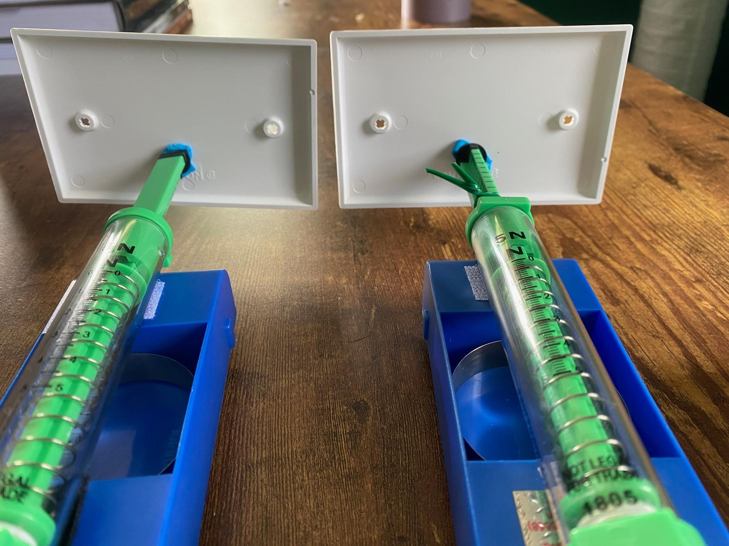
  Show students how to tape the potential protective material on the electrical plates by creating a tape circle with the sticky side facing outward. | 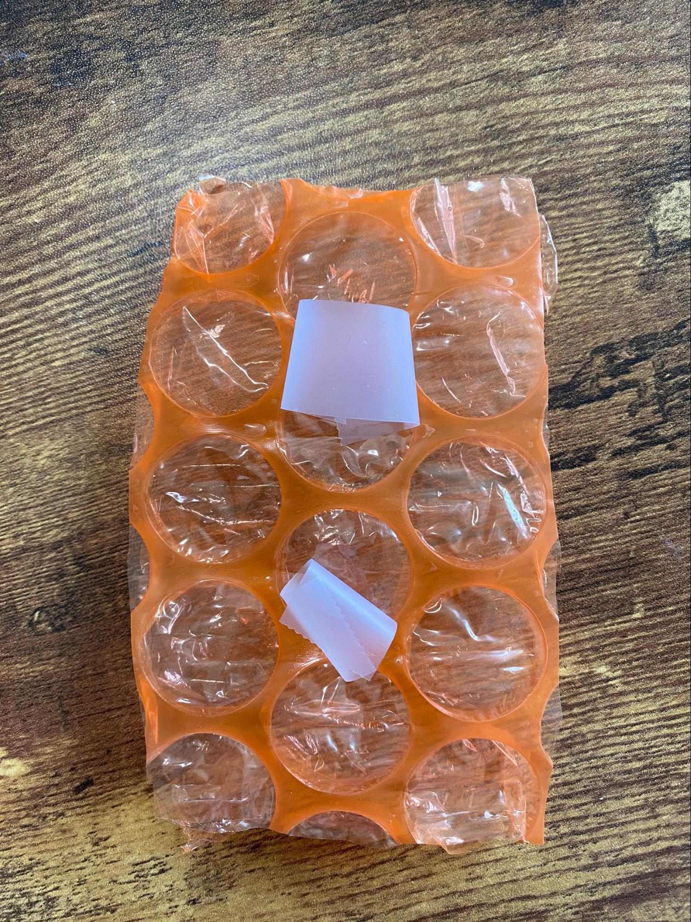
  Attach a material to the front of both electrical plates and show how they line up when the two carts come into contact. Explain that as long as the materials are in the middle of the collision, it should give the data we need. | 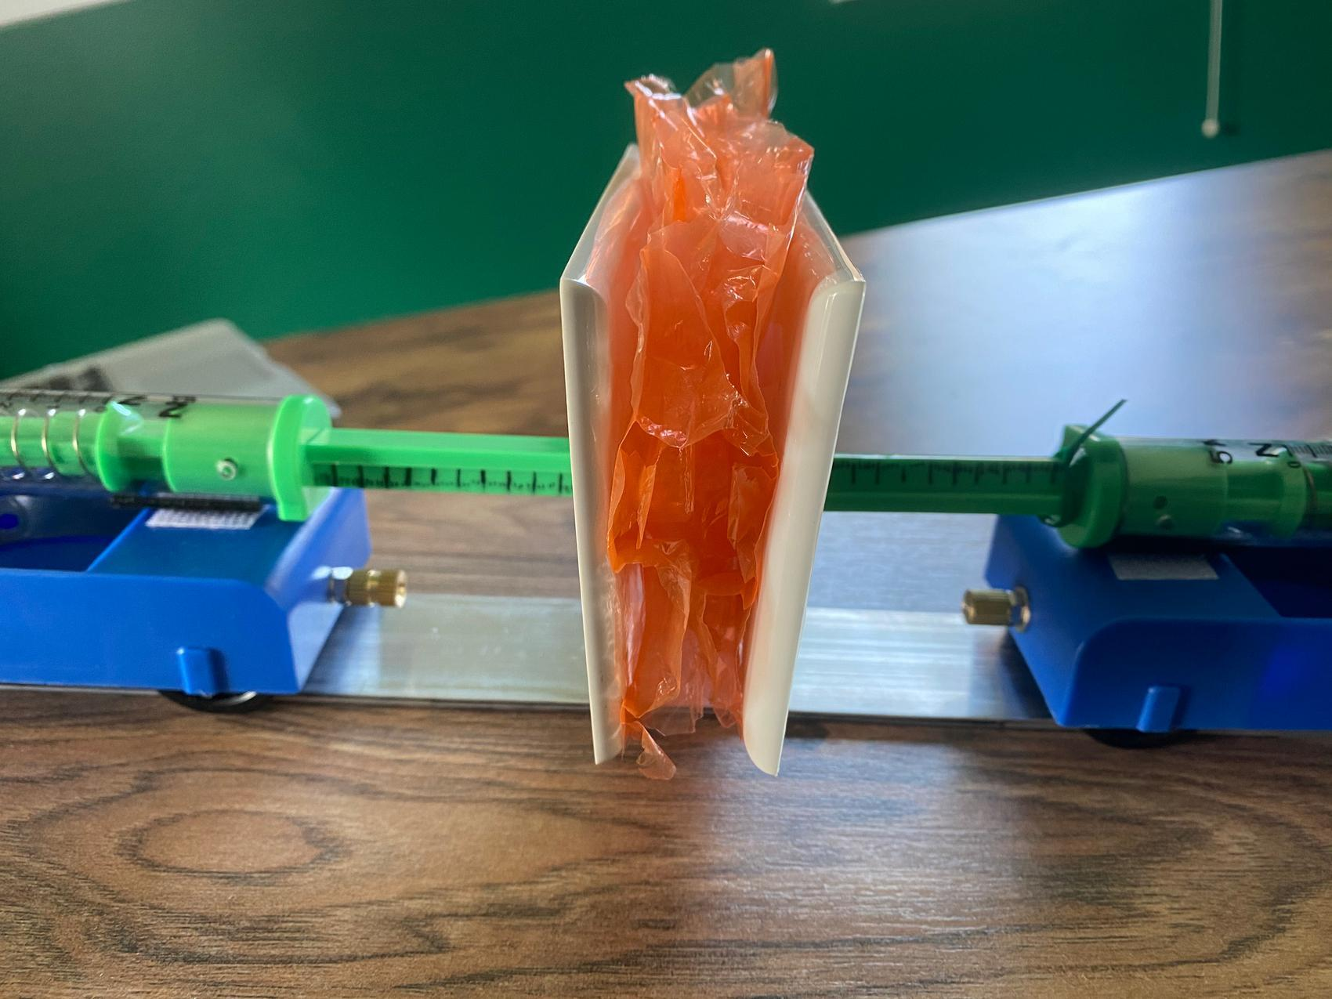
  Remove the protective material from the front of the electrical plates. Demonstrate for students how to set up the spring scale setup (see video in the Lab Preparation section), making sure to point out again how to adjust the electrical plates so they are flush with each other at contact. By removing the padding at this moment, students can see how well the blank electrical plates line up without the visual interference of the protective materials. | 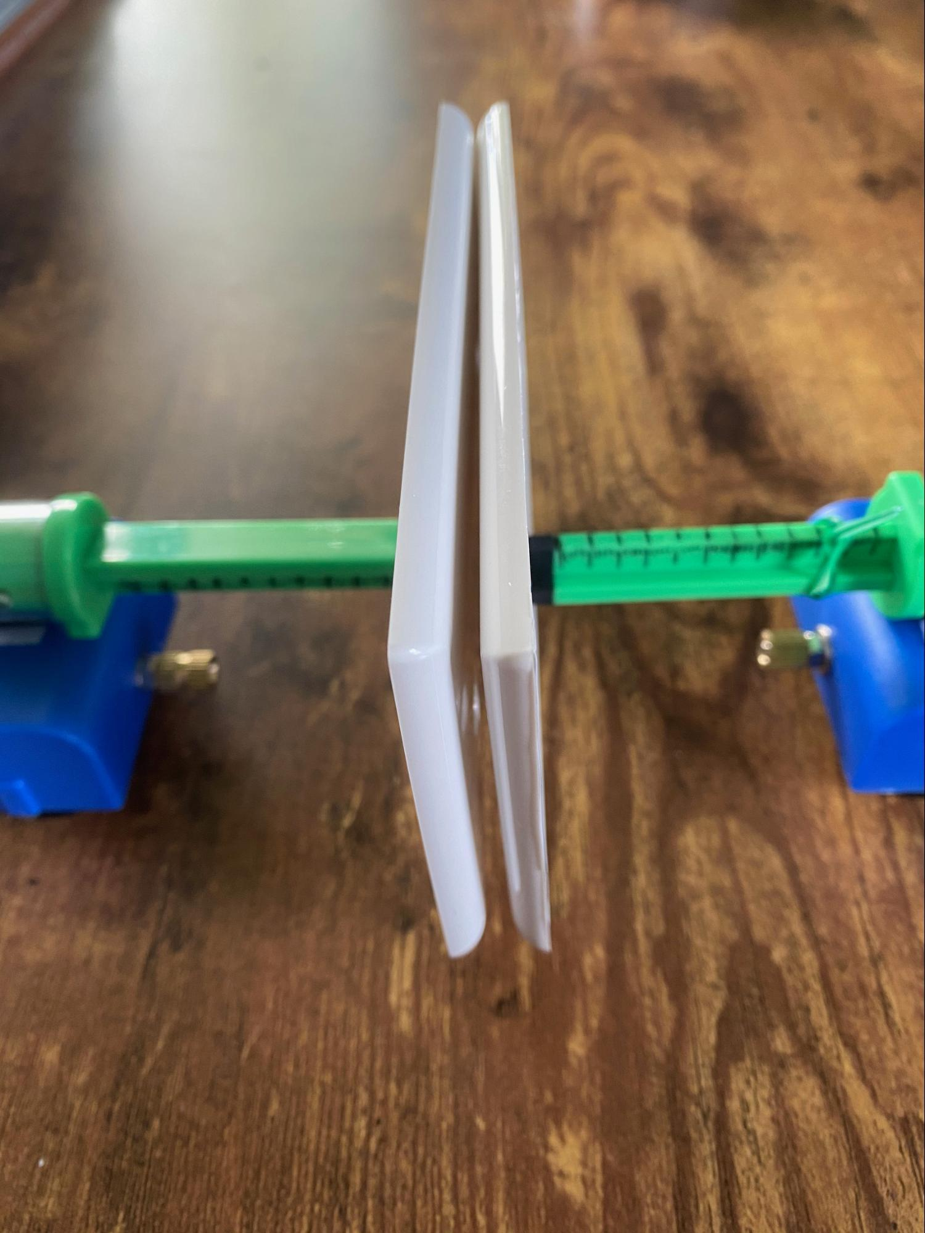
  Review that this force collar setup will allow us to observe the peak amount of force on our carts during the collisions. Using duct tape, secure the nonmoving cart 4 inches away from the brick. | 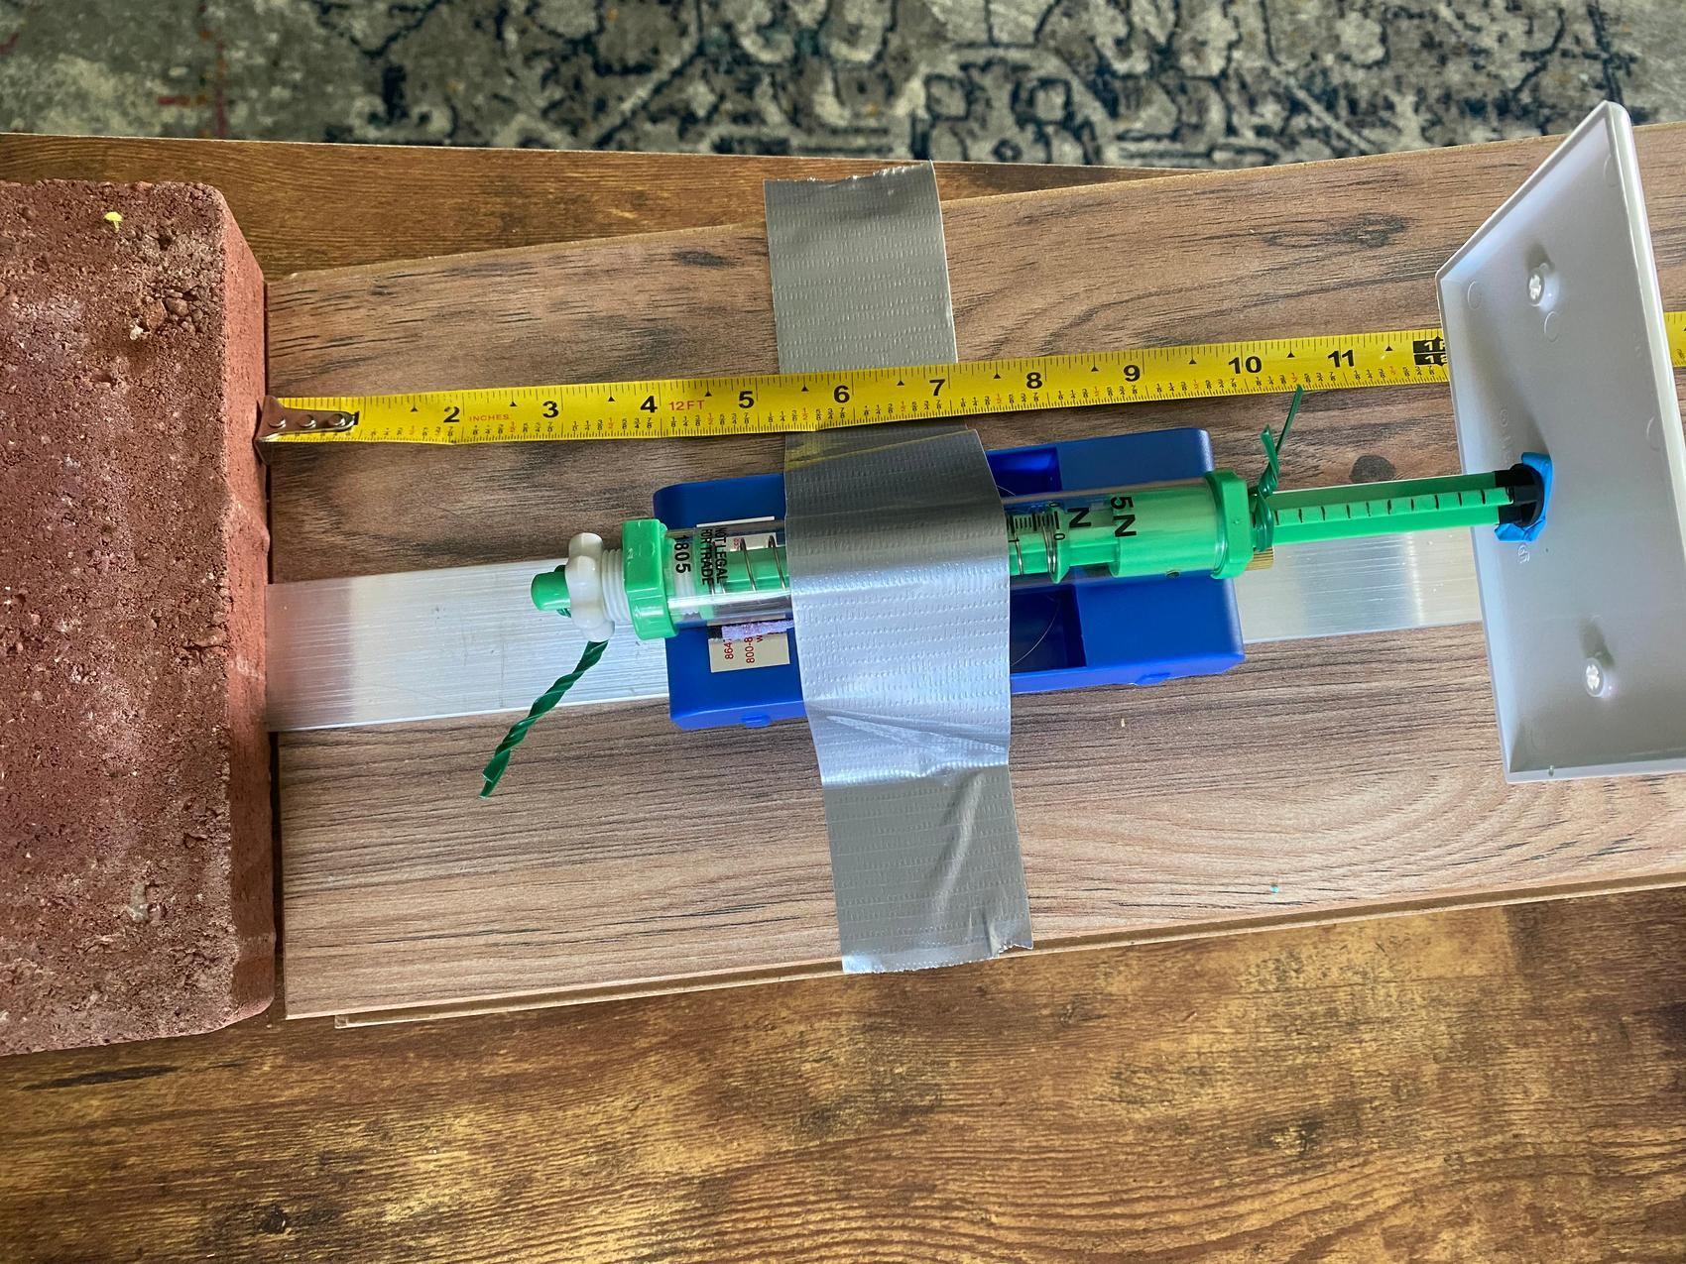
  Draw attention to the force collar. Show students that the force collar is on the “0” mark on the nonmoving cart. | 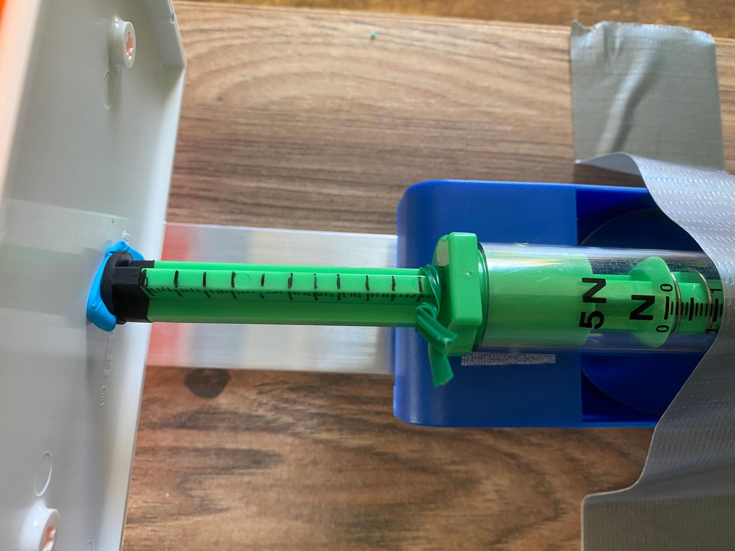
  Place the moving cart at the top of the ramp. Release the moving cart towards the nonmoving cart. After the collision, observe where the force collar rests on the nonmoving cart. Point out to students the new location of the force collar and review how to read the measurement consistently at the back of the twist tie. Remind students that each mark represents 1/10 of a newton. | 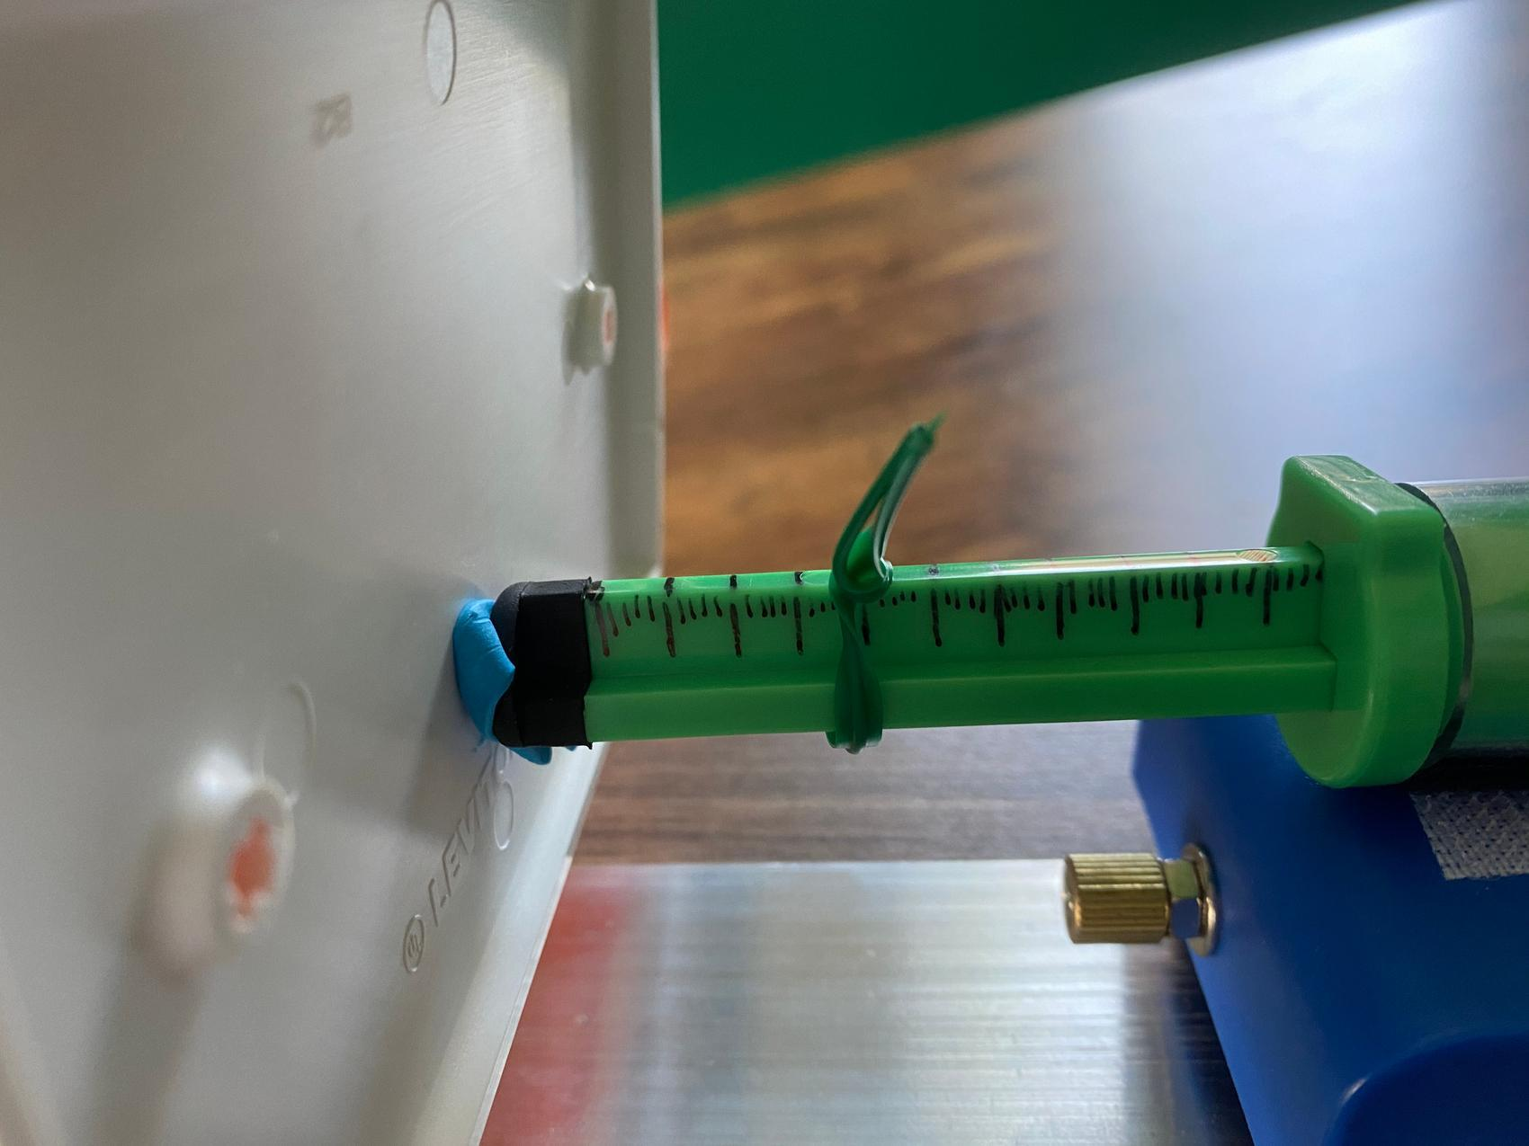
  ADDITIONAL GUIDANCE | Students may ask why we are using the ramps rather than the spring-scale launchers for this investigation. If they do, you can say the spring-scale launchers provide a way to ensure that we are doubling the speed of a cart launch by pulling back the plunger twice as far, but they tend to have more variability in their results because of how hard it is to make sure we are pulling back the plunger to exactly the same point on the plunger in repeated trials. But the ramp is easier to ensure that we pull the cart back to the same point on the ramp each time, though it is less useful for doing experiments where we want to double the speed of the launch, which is not the goal of this investigation.

4 · CONDUCT MATERIALS TESTING | 18 min
MATERIALS: Materials Testing Lab
Calibrate group devices. Project slide G. Direct students to set up the spring scale, cart, track, flooring strip, books, and brick in the same arrangement as the teacher demonstration setup. Distribute a piece of duct tape to every group for students to secure the nonmoving cart. Instruct students to follow the directions on the slide to calibrate their spring scales. Explain that it is important to calibrate the spring scales first so we can accurately compare the potential force reduction data from our materials testing.  - Check your spring scales. Do they show 0 newtons when held horizontally?  - Push in and out on the spring scale rod a couple of times and make sure that it rests at 0 newtons.  - If it is not at 0, use the white screw on the end to adjust the scale. Once you have it set, push in on the rod and let go to check that it rests at 0 newtons.  Distribute testing procedures. Project slide H. Distribute Cushioning Materials Testing Procedures to students. Read through the directions with students and have them highlight or star the places where they will stop and record their data. Point out the differences between the two data tables and explain how to use the subtraction table located in the final section to help students find the difference in peak forces during the collisions.  Conduct materials tests. Display slide I. Once it has been verified that all the devices are calibrated, have students run 6 tests without the protective material in the system and record the data for each trial on their handout. Students will need to establish a baseline, or control, for their readings to determine if the protective materials actually reduce peak force on their objects.✱ Explain that there are variables that we cannot control for in the way we set up our work stations (e.g., some wheels may be slicker than others, some peak force collars may be slightly tighter than others), but by comparing the peak forces of the control and the experimental trials at each station, we will get a better picture of the overall peak force reduction potential of the materials.  Remind students to use tape, not sticky tack, during the second part of the investigation to add their material on the carts’ electrical plates. Make sure students keep the test materials in line with the plunger as much as possible. Students will run each test 6 times, then average their data.  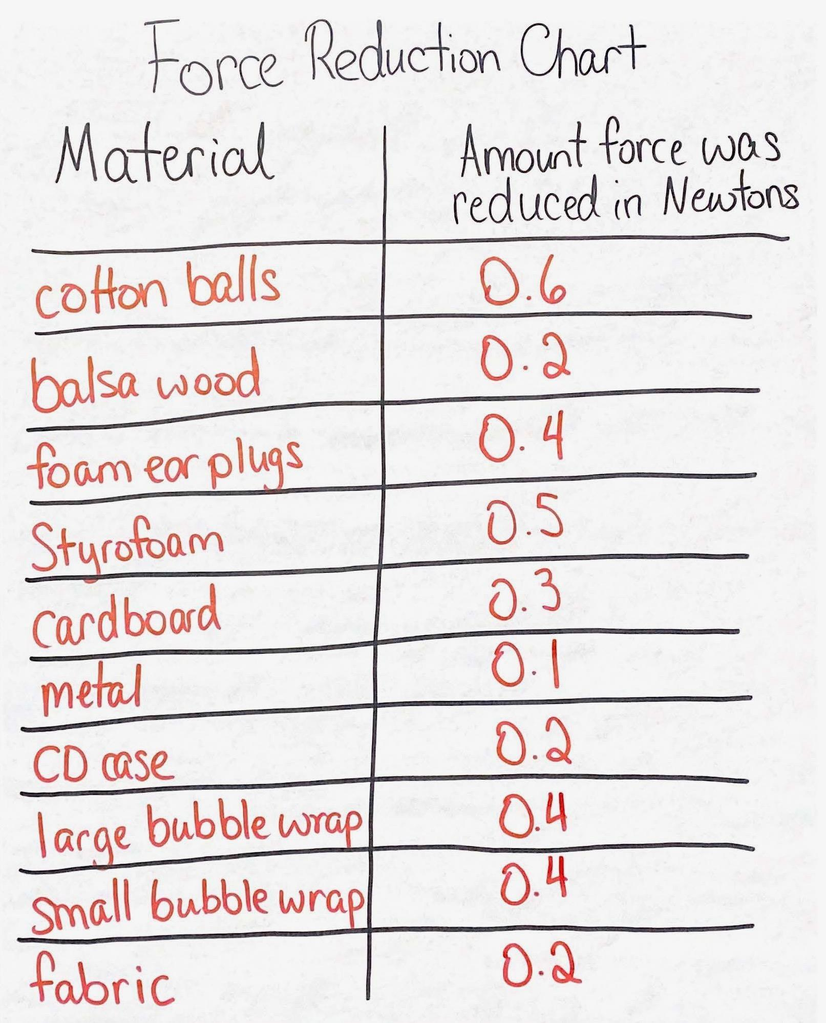  After data collection is completed, students will then find the difference between the control peak force average and their materials test peak force average and add it to the class chart. These data will be reviewed individually and as a class during the next class period and should be checked as students are recording their data. Once students are finished adding their data to the class chart, have students dismantle their lab setup, put away materials, and return the protective materials for use in the next class period. Here is an example of a completed class chart. | ✱ SUPPORTING STUDENTS IN ENGAGING IN PLANNING AND CARRYING OUT INVESTIGATIONS  Over the course of the units in OpenSciEd, students develop their skill of planning and carrying out investigations. Here, the idea of establishing a baseline as a control condition is discussed with students. The data from each trial or setup might be slightly different based upon slight, uncontrollable changes to the cart, positioning, and so forth, but the overall change to the peak forces in the system can be compared from one protective material to the next. While we cannot control for everything in the system, the peak force comparisons of the control to the experimental trials will allow for better comparison of all the protective materials.  ✱ SUPPORTING STUDENTS IN ENGAGING IN PLANNING AND CARRYING OUT INVESTIGATIONS  Testing specific materials leads to an understanding of which types of materials help to reduce peak forces in a collision. The testing of materials provides evidence that will serve to better refine design solutions. By understanding which materials work better to reduce peak forces, students can make an informed decision to modify devices to better meet their criteria and constraints, which will be built upon in Lesson 14.
  ADDITIONAL GUIDANCE | During this investigation students work in small groups to run and record data for multiple trials and calculate the averages in the data for a control condition and for an experimental condition with one cushioner on Cushioning Materials Testing Procedures. Students use these data to determine the average amount of force reduction in their cushioner. As students are working, circulate and assist students. Make sure students are  - recording multiple trials,  - calculating averages for both the control and the experimental condition, and  - calculating the difference between the control and the experimental conditions.  If the data seem skewed, have students look back at the raw trial data from the lab. If students find more than 0.2 N variance from the mode of their measurement, they should be encouraged to check that the collar isn’t loose and re-run that trial.
  ADDITIONAL GUIDANCE | In the next class period, students will look for consensus on identifying the top 3 to 5 materials that seemed to work best to reduce peak force.  These materials should include  - one or both types of bubble wrap  - foam earplugs  - Styrofoam  - cotton balls  If at least three of the top performers listed above don’t appear in a class set of data at the end of day 1, have that class compare their data to another class's data at the start of day 2. Emphasize that more data can make us more certain and have students look for patterns across class data sets (e.g., which materials are in the top five performers in the most classes).

End of day 1
5 · COMPARE CLASS DATA | 6 min
MATERIALS: science notebook
Individually reflect on results. Display slide J. Have students look back at the data collection table from last time. Instruct students to reflect on the data and answer the following questions in their notebooks:
- What materials seemed to do the best at reducing peak force on the nonmoving object?
- What patterns in material structure do you see in these “top performers”?
- Think about the materials. What special features or properties of the material’s structure would make it function better than a worse-performing material?
- How do you think the structures of the materials behave in a collision that would reduce the peak forces on the objects?
- Was the peak force reduced on both objects or just on the nonmoving object?

ADDITIONAL GUIDANCE | The second and third questions on slide J are presented to get students thinking about the function of those structural patterns they are observing. Students will come back to these ideas after investigating potential force differences in a collision with a protective material.

ASSESSMENT OPPORTUNITY | Building towards: 12.A Analyze data to determine which materials reduce peak force in a collision and analyze the similarities (visual patterns across materials) in the properties of those materials (macroscopic deformability).  What to look for/listen for  - As students are individually reflecting on data, they should write about the patterns they see across multiple structures that were top performers. Students should identify that the better performers have space and/or air gaps in them and the ability to deform more than other materials that did not perform as well.  What to do  - If students do not identify similarities in better-performing materials, encourage students to go check out all 10 materials to feel and see if there are similarities in the behavior and structure of the materials.  - Have students describe the structure of 2 different materials that performed well and have them look for patterns in the structures of those materials.  - Have students apply a force (e.g., with their fingers or a spring scale) to each of the materials and describe what seems similar between the materials that were better performers.

6 · REVIEW DATA AS A CLASS | 4 min
MATERIALS: Up Close Images, Force Reduction Chart
Review materials data to determine which reduced peak forces best. Display slide K. Ask students to turn and talk about the questions on the slide. After 2 minutes, bring the class back together and discuss the questions as a whole class.
- What materials were our “top performers” that seemed to work best to reduce peak force on the nonmoving object?
- What patterns in material structure did you see in the “top performers”?
- Did the material reduce the peak force on both objects or just on the nonmoving object?

Have students share out their ideas. Sample student responses are below.

Suggested prompt | Sample student response
What materials were our “top performers” that seemed to work best to reduce peak force on the nonmoving object? | The cotton balls, bubble wrap, Styrofoam, and foam earplugs did the best. (This may vary by class.)
What patterns in material structure did you see in the “top performers”? | Some of them had air gaps.  Some materials seemed to be able to bend more.
Did the material reduce the peak force on both objects or just on the nonmoving object? | We saw the reading on the scale on the nonmoving cart change with the material attached, but the moving cart did not have a collar so we did not measure the peak force on it.  The collar still seemed to move, but it moved less than the trials without the test materials.

Say, Interesting, we didn’t collect data on the other cart, so we can’t be sure that it reduced peak forces on both carts in the collision.

Ask students the following question: What do you think would happen to the peak forces on both objects if one cart had more kinetic energy than another cart before the collision, either by an increase in weight or increase in speed?

Allow students to respond to the question. Students may bring up the following ideas:
- In Lesson 5 we figured out that the peak forces should be the same, but we are not sure if that is still the case when there is some type of material in between them.
- Maybe the padded material just protects the nonmoving object more.

Draw attention to the idea that we know from Lesson 5 that the objects involved in a collision both push on each other equally, but when we add a material in between we can’t be sure that the force isn’t reduced by the material, causing one side to experience more peak force than the other. We also had the carts calibrated to be the same mass as we conducted our investigation on day 1.

7 · COMPARE FORCES ON BOTH OBJECTS WITH PROTECTIVE MATERIALS | 8 min
MATERIALS: 1 5-N spring scale, 1 10-N spring scale, 1 force-reducing material from Materials Testing Lab
Say, I think I have a way we can figure this out. Let’s see if we add a material in between two spring scales to see if the forces are reduced on one object or both objects equally.

Compare spring scales of different measurements. Project slide L. Pass out 1 5-n spring scale and 1 10-n spring scale to each group. Ask students to push the two scales together and observe the readings on each scale. Instruct students to select one protective material and place it in between the two scales. Students will use both scales to gently push in on the protective material and observe the reading on both scales. Have students swap out a scale and protective material with another group so that each group has 2 of the same spring scales and repeat the instructions.

Project slide M. Read the questions on the slide. Have students turn and talk about their ideas with a partner or their small group before sharing with the whole group.

Suggested prompt | Sample student response
As you pushed in on each scale, what did you notice happening to the protective material? | The protective material was bent or squished. Most of the materials seemed to deform.
What did you notice about the readings on each scale? | Even though the scales were made to measure more or less force, the reading was about the same when we pushed in on them, and it didn’t matter what we had in between them. They experienced the same amount of force.
What felt different about pushing the scales with and without the protective material between them? | When we had the protective material in the middle, we had to push a bit more to get the same reading that we had without the protective material.  The materials felt more squishy or bendable for the materials that reduced peak force more.

Say, Interesting, the really protective materials seem to reduce the forces on both objects, regardless of the strength of those objects. It also seems that the really protective materials acted a little differently than the only slightly protective materials when we pushed on them. They may have moved easier or had different properties even though they are all solids. What is special about those force-reducing materials that you identified last class?

Ask students what they think is different about materials that reduce peak force more than other materials. Students should list things such as these:
- They are squishier.
- They seem to be lighter.
- They can bend more.

Some students may want to look at the materials more closely. Explain to students that we can get a better idea of what might be happening by looking closer at the material properties. Tell students that we do have some microscopic images that might help us explain how the properties of the better protective materials differ from the properties of materials that did not reduce peak force as well.

8 · COMPARE MATERIALS AND EXPLAIN MATERIAL STRUCTURE | 8 min
MATERIALS: science notebook, How do we sense different textures? (optional), Up Close Images
Share perceived material property differences. Display slide N. Distribute Up Close Images to partner pairs. A color copy can also be found in the Student Procedures. Show students the different zoomed-in images of the various protective materials that we have tested and give time for students to look over the images on the handout. Have students turn and talk with a partner about what they see in common with the protective materials.

Project slide O. Ask students to look back in their notebook to their responses about the specific features of materials that might be causing a reduction in peak forces. Have students share with a partner the specific features that they think contribute to the reduction of peak forces. They may revise any of their ideas at this time.

After students have had a chance to share with their partners, have students share with the whole class their ideas about perceived features. Students should identify these characteristics:
- The materials can deform more than the materials that don’t reduce peak force as much.
- The materials can change shape easily.
- The materials seem to have space for air or air pockets.

Say, Interesting. It seems that we all think that the materials have air space or pockets in them and that may contribute to how they help reduce peak forces in a collision. One material we know that definitely has air pockets is bubble wrap. Let’s look at bubble wrap and cotton balls together and see what happens as we apply a force with our hands. Maybe if we use our finger sensory receptors that help us detect forces on our fingers, we can try to explain what the bubble wrap and cotton balls are doing as we apply a force.

ADDITIONAL GUIDANCE | Extension Opportunity: In a prior activity, students manipulated the test materials by placing them in the middle of two spring scales and applying a force. Students may have noted that these test materials all feel soft or are easily pliable. This may lead to some curiosity about why certain objects feel squishy or soft. The reading How do we sense different textures? helps explain why we sense different sensations such as soft, hard, smooth, rough, dull, and sharp. If students are interested in learning more about how contact forces applied to the skin lead to these different sensations, they can read How do we sense different textures?. This reading is optional and will not affect the overall conceptual understanding of why some materials work better than other materials at reducing peak forces in a collision, but it may help answer some student questions on the Driving Question Board. Check your Driving Question Board to see if this will aid your students in figuring out the answers to any of their questions. If this reading will help address some questions on the Driving Question Board, consider assigning the reading to the class.

9 · CONSTRUCT INDIVIDUAL MATERIAL EXPLANATIONS | 14 min
MATERIALS: 1 1”-square piece of small bubble wrap, 1 cotton ball, How can materials reduce peak force on the objects they protect?
Introduce handout. Display slide P. Distribute How can materials reduce peak force on the objects they protect?. Show students the two “Time point” boxes. Explain that the first box is for showing what the bubble wrap or cotton ball is like before a collision occurs. The second box is to identify the parts of the structure(s) they think are important and to show what happens to the structures of the bubble wrap or cotton balls as a contact force is applied. Ask students to use the second box to try to explain what the zoomed-in structures of the material are doing during a collision that helps to reduce the peak forces on the objects involved.✱✱  Distribute bubble wrap and cotton balls. Pass out a small piece of bubble wrap and a cotton ball to each student. Let students know that they will get only one small piece of bubble wrap, so they need to refrain from popping the bubble wrap until we are all done explaining how they think the material helps reduce peak force on the objects.  Allow students time to draft their ideas. With 2-3 minutes left in class, shift the focus to the last question. Have students try to explain the last question on the handout:  - How are these changes helping to reduce the peak forces?  Collect How can materials reduce peak force on the objects they protect? at the end of class. Look for varying differences and explanations in the ways the protective material might be reducing peak forces. These varying ideas can be utilized to motivate student learning in Lessons 13-14. Ask students to throw away their bubble wrap as they leave class. Depending on the type of bubble wrap material, some types of bubble wrap can also be recycled.  Additional Lesson 12 Teacher Guidance | ✱ SUPPORTING STUDENTS IN DEVELOPING AND USING STABILITY AND CHANGE  At this moment, students are taking the observable features that occur during a collision and their knowledge about forces and applying this to create a model of microscopic changes that occur during a collision. These microscopic changes are being applied to explain how some materials reduce force on the objects that they are protecting and how their structures change over the duration of the collision.  ✱ SUPPORTING STUDENTS IN ENGAGING IN DEVELOPING AND USING MODELS  In Lesson 11, students drafted ideas on how a material might reduce the peak force on the object it is protecting. Since then students have conducted an investigation to determine which readily available materials reduce peak force more than others and have observed the structures at a microscopic scale, looking for patterns in those structures that might contribute to a reduction in peak force. As students model the materials in the handout, the structures should become more detailed, and they should start to make connections about the ability of some materials to deform more easily than others due to changes occurring in their structure at a microscopic scale when forces are applied to them. Giving students the experience to incrementally revise this model, such as this opportunity here, will aid in their conceptual development of the target science ideas.
  ALTERNATE ACTIVITY | If bubble wrap waste is an issue, consider having students not pop their bubble wrap and use the same pieces class after class as a non-consumable. Collect the unpopped bubble wrap at the end of class.
  ASSESSMENT OPPORTUNITY | Building towards: 12.B Construct a model to explain how the changes in the structures of cushioning materials contribute to their function (a reduction in peak forces) at a microscopic level during a collision.  What to look for/listen for  - Bubble wrap and cotton balls have a large amount of empty space or air in them and relatively small amounts of solid material across the space they take up.  - Bubble wrap and cotton balls deform easily when a small force is applied.  - Connecting structure to function, identifying a connection to reduction in peak force: e.g., less force between the cushioner and the objects it is in contact with is due to increased space, ability to deform, less-solid material, more-flexible material, and so forth.  - Possible student idea: Students may bring up particle-level connections, e.g., these materials are ones that would also exhibit less energy transfer through conduction (from prior units the [unit:wc] and [unit:th]), which may be related to less peak force in a collision.  What to do  If students are not showing the deformation of materials on How can materials reduce peak force on the objects they protect?, have students use their fingers to apply a contact force to the bubble wrap or cotton ball and observe the surface of the bubble wrap and cotton ball. Ask students what the bubble wrap or cotton ball is doing: Is it breaking or is it doing something else when a contact force is applied?  At this point, students have not learned about the deformation differences between solids and gases, but this could be inferred by some students based upon prior learning in the Storms Unit, Bath Bombs Unit, and Cup Design Unit. Some students may be able to show the air becoming more dense upon impact in the bubble wrap or the air moving out of the cotton ball. Since this is a new use of this key concept, ask students to do their best. They will learn more about this in Lessons 13-14. There is no need for intervention on this concept until the end of Lesson 14.
  SUPPORTING STUDENTS IN MAKING CONNECTIONS IN ELA | CCSS.ELA-LITERACY.W.8.1  Write arguments to support claims with clear reasons and relevant evidence.  CCSS.ELA-LITERACY.W.8.1.B  Support claim(s) with logical reasoning and relevant evidence, using accurate, credible sources and demonstrating an understanding of the topic or text.

